|  |
| --- |
| chk_captcha |

**Faculty of Computer Science & IT**

**Department of Computer Science**

**Final Year Project**

**PROJECT REPORT (Part-1)**

**[Performance Based Management** **System]**

**Project Team**

|  |  |  |  |  |
| --- | --- | --- | --- | --- |
| **Student Name** | **Student ID** | **Program** | **Contact Number** | **Email Address** |
| Mubeen Liaquat | BCSM-S17-077 | BCSM | 03014024415 | BCSM-S17-077@superior.edu.pk |
| Nouman Sami | BCSM-S17-055 | BCSM | 03040424006 | BCSM-S17-055@superior.edu.pk |
| Hassan Ali | BCSM-s17-063 | BCSM | 03204667538 | BCSM-S17-063@superior.edu.pk |

**Chapter No 1. Introduction**

We are providing platform to faculty members to give feedback to the university. The system that was current being used is manually which cause faculty members to submit their feedback at the end of the year. We are providing the efficiency of the system by divided into parts that allows faculty member to submit their feedbacks at the end of months. We are implementing that system which restrict our teachers to submit their feedback at the end of month otherwise they are not be able to mark the attendance of students of next month. We divided yearly system to monthly system. Which reduces the efforts of our teachers, and its also less time consuming to submit their monthly feedback with respect to yearly feedback submission system.

* 1. **Background**

We are developing the website for this system called “**Performance Based Management System**”. The teacher will submit their feedbacks on monthly basis instead of yearly. We make it essential for our teachers to submit their feedbacks otherwise they will be restricted and not be able to marks the attendance of the students until the feedback will be submitted.

* 1. **Motivation And Challenges:**

We are developing this management system for the ease and for the efficiency of time. There is less burden on teachers and less manual effort to put on our system to view the efficient result. Our challenge is to manage our team and divide work in equal parts. So all team members can work easily. And put their best effort on this system to ensure the efficient results.

* 1. **Goals And Objectives**

Our goal is to develop that system and fulfill the requirements of that system. So it will be more efficient to use and less time consuming. This system is capable of reduce the manual work. Team work is a key to success. So we work as a team and we will develop this system in given duration of time.

**1.4 Functional requirements**

User & faculty login**:** User and faculty can login with a registered account.

User & faculty registration**:** User and faculty can be registered themselves.

User posting projects**:** User can post his or her require work with a little description and budget.

Faculty selecting projects**:** Faculty can browse and select from different tasks.

User accepting available faculty**:** User can accept the faculty who wants to work with.

**1.5 Existing Solution**

No online management system available yet.

**1.6 Gap Analysis**

* **Existing**
* Collection of less information.
* Required more time.
* Difficulty in sharing information.
* Difficulty collecting data on daily Bases.
* Difficulty in evaluating staff performance.
* Difficulty in making aware of current situation in less time.
* **New**
* More and easier to gather accurate information.
* Less time required.
* Ease of sharing information.
* Ease of collecting data on daily bases.
* Ease of evaluating staff performances.
* Ease of being aware of current situation in less time.

**1.7 Proposed solution**

* More and easier to gather accurate information.
* Less time required.
* Ease of sharing information.
* Ease of collecting data on daily bases.
* Ease of evaluating staff performances.
* Ease of being aware of current situation in less time.
* Teacher’s performance management system is a continuous process for identifying, evaluating and developing the work performance of teachers, so that the goals and objectives of the institute are more effectively achieved, while at the same time benefiting teachers in term of recognition of performance, professional development and career guidance.

**1.8 Project Plan**

We are developing a performance based management system for our faculty members, as we know the form that we are developing online is currently in hard form that is given to teachers after a year for their feedback and performance evaluation.

* First we have to gather requirements.
* Then we design our system including database and login page.
* Testing
* Deploy
* **1.8.1 Work Breakdown Structure** 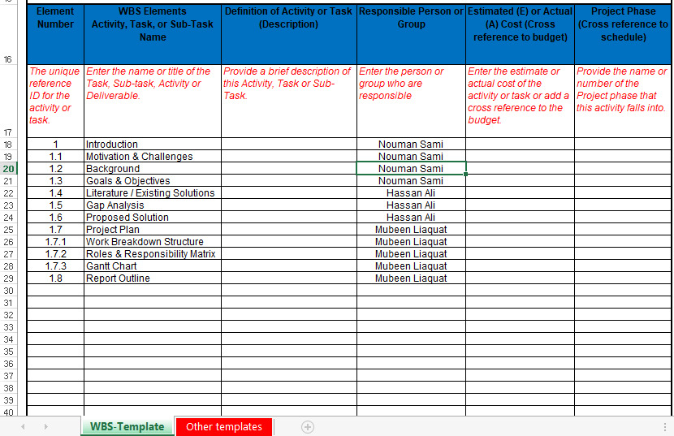

**1.8.2 Role & Responsibility Matrix**

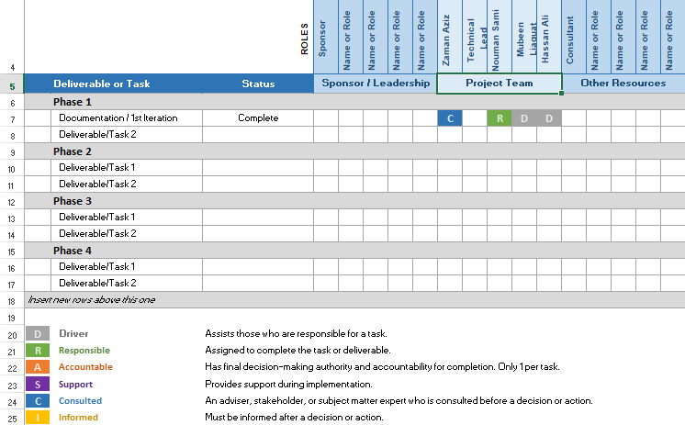

**1.8.3 Gantt Chart**

**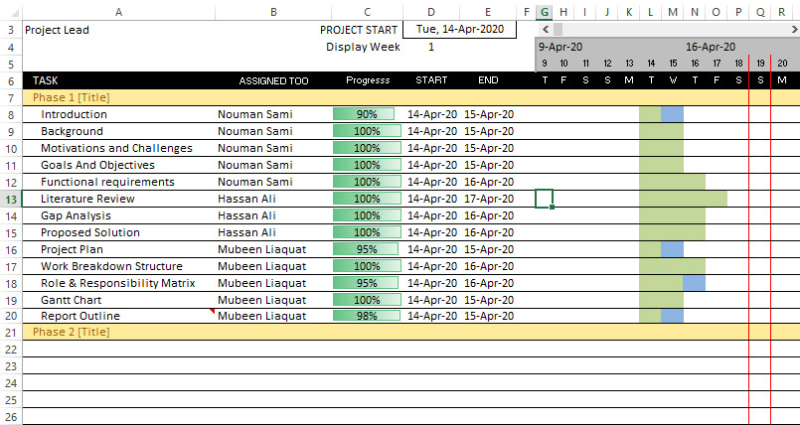**

**1.9 Report Outline**

We are providing platform to faculty members to give performance evaluation to the university. The system that was current being used is manually (Hard Form) which cause faculty members to submit their performance evaluation at the end of the year. We are providing the efficiency of the system by divided into parts that allows faculty member to submit their evaluations at the end of months. We are implementing that system which is easy to use and more sufficient in use. We divided yearly system into monthly system. Which reduces the efforts of our teachers, and it’s also less time consuming to submit their monthly performance evaluations with respect to yearly performance evaluation management system.